Covid PCA and machine learning analysis of global data by countries

- Google search: PCA principal component analysis Covid-19

1.9 million results : three independent things in top 10

B. Advanced Google Search
PCA principal component analysis "Covid-19"
Last updated within last month

A
- https://www.medrxiv.org/content/10.1101/2020.04.24.20078238v1.full.pdf
- Uses Worldometer : the data repository and the free reference website
- Top 133 countries
- April 2020 : ie covers early response only.
- Linearly transformed the following correlated measures to a linearly indept set:
- total confirmed cases, new confirmed cases, total deaths, total recovered patients, total active case, total seriousely critical patients, infection rate in million, death rate in million, total tests conducted, and test rate in million
- Then did PCA on all data together to cluster countries.

80% of variance explained by first 2 principal cpts. 20% from 2nd principal cpt (linked to popln size)
60% of variation from countries: USA, Spain, Italy, France, Germany, UK, and Iran
two clusters among the variables and four clusters among the countries.
Three rate variables together– tests, cases and deaths per milllion forms one cluster while the remaining seven variables together forms the second cluster among the variables.
Four major clusters among the countries. Table shows the full list of the clusters. The first cluster contains all the countries that contributed to the first principal component’s variation in PCA analysis along with China.
Cluster | Country
Cluster 1 (n=8) | USA, Spain, Italy, France, Germany, UK, China, Iran
Cluster 2 (n=43) | Afghanistan, Australia, Austria, Belarus, Brazil, Brunei, Burkina Faso, Cameroon, Canada, Congo, Cyprus, Czechia, Denmark, Diamond Princess, DRC, Estonia, Finland, Guadeloupe, Guinea, Hong Kong, Israel,  Ivory Coast, Kuwait, Latvia, Lithuania, Madagascar, Mali, Martinique, Netherlands, New Zealand, Norway, Oman, Portugal, Qatar, Russia, Runion, S. Korea, Senegal, Singapore, Slovenia, Sweden, Turkey, Venezuela
Cluster 3 (n=14) | Andorra, Bahrain, Belgium, Channel Islands, Faeroe Islands, Gibraltar, Iceland, Ireland, Isle of Man, Luxembourg, Malta, San Marino, Switzerland, UAE
Cluster 4 (n=68) | Albania, Algeria, Argentina, Armenia, Azerbaijan, Bangladesh,  Bolivia, Bosnia and Herzegovina, Bulgaria, Cambodia, Chile, Colombia, Costa Rica, Croatia, Cuba, Djibouti, Dominican Republic, Ecuador, Egypt, El Salvador, Georgia, Ghana, Greece, Guatemala, Honduras, Hungary, India, Indonesia, Iraq, Jamaica, Japan, Jordan, Kazakhstan, Kenya, Kyrgyzstan, Lebanon, Malaysia, Mauritius, Mayotte, Mexico, Moldova, Montenegro, Morocco, Niger, Nigeria, North Macedonia, Pakistan, Palestine, Panama, Paraguay, Peru, Philippines, Poland, Romania, Rwanda, Saudi Arabia, Serbia, Slovakia, South Africa, Sri Lanka, Taiwan, Thailand, Trinidad and Tobago, Tunisia, Ukraine, Uruguay, Uzbekistan, Vietnam

Diabetes Metab Syndr. 2020 September-October; 14(5): 1231–1240.
Published online 2020 Jul 9. doi: 10.1016/j.dsx.2020.07.008
PMCID: PMC7347321
PMID: 32683321

Data-driven modelling and prediction of COVID-19 infection in India and correlation analysis of the virus transmission with socio-economic factors
Amit Kumar,ª Poonam Rani,^{a,∗} Rahul Kumar,^{b} Vasudha Sharma,^{c} and Soumya Ranjan Purohit^{d}

Aims
The current study attempts to model the COVID-19 outbreak in India, USA, China, Japan, Italy, Iran, Canada and Germany. The interactions of coronavirus transmission with socio-economic factors in India using the multivariate approach were also investigated.

Methods
Actual cumulative infected population data from 15 February to May 15, 2020 was used for determination of parameters of a nested exponential statistical model, which were further employed for the prediction of infection. Correlation and Principal component analysis provided the relationships of coronavirus spread with socio-economic factors of different states of India using the Rstudio software.

https://rpubs.com/HeatWave2019/624567

Statistical Modelling for COVID-19

with PCA Analysis, GLM and LMM

DKCH

2020-06-06
Abstract
COVID-19 pandemic is outbreaking to worldwide countries starting from December 2019. Four main tasks in this mini project include visualization COVID-19 data with PCA and the modeling of numbers of deaths caused by COVID-19 with Quasi-Poisson Regression, Quasi-Binomial Regression, and the Linear mixed model respectively. PCA result suggests three optimal clusters for COVIS-19 data. Quasi-Poisson Regression analysis suggests six latent factors to describe the number of deaths. Quasi-Binomial Regression analysis suggests two contradictory results. Linear Mixed Model suggests two positive fixed effects and three negative fixed effects for an explanation of the variations in the number of deaths caused by COVID-19.

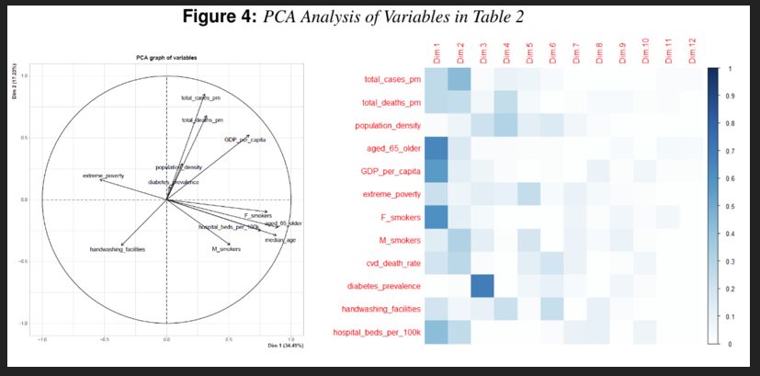

B Advanced search

Principal component analysis to study the relations between the spread rates of COVID-19 in high risks countries
Author links open overlay panelMohammad RezaMahmoudi^{ab}Mohammad HosseinHeydari^{c}Sultan NomanQasem^{de}AmirhoseinMosavi^{fg}Shahab S.Band^{h}
Show more
https://doi.org/10.1016/j.aej.2020.09.013

In this research, the number of patients with Covid-19 and the number of deaths due to this disease in France, Germany, Iran, Italy, Spain, United Kingdom, and Unites States America are considered. First, the relations between the considered countries are studied using Pearson’s correlation. Then, based on the spread rate of Covid-19, these countries are categorized using principal component analysis.

NLR combined with SaO2 predict severe illness among COVID-19 patients: a currently updated model
- August 2020
- DOI:
- 10.21203/rs.3.rs-64080/v1

Conclusions: It showed that NLR+SaO2 is an appropriate and promising method for predicting severe illness, followed by PCA.

